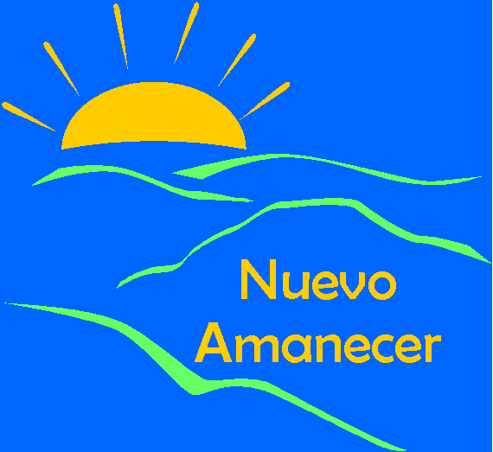
Please help us evaluate this training for the Nuevo Amanecer program.
Date: ______________

Your opinions are very important to help us improve the program.

 | Poor | Fair | Good | Very good | Excellent
- How would you rate the overall quality of this training program? | 1 | 2 | 3 | 4 | 5
- How clear was the information? | 1 | 2 | 3 | 4 | 5
- How well do you feel that this training prepared you to support Latinas with breast cancer? | 1 | 2 | 3 | 4 | 5
- How well do you feel that this training prepared you to give Latinas information about their diagnosis and treatment for breast cancer? | 1 | 2 | 3 | 4 | 5
- How well do you feel that this training prepared you on how show Latinas with breast cancer how to handle stress? | 1 | 2 | 3 | 4 | 5
- How well do you feel that this training prepared you to show Latinas with breast cancer how to change negative to positive thoughts? | 1 | 2 | 3 | 4 | 5
- How well do you feel that this training prepared you to show Latinas with breast cancer how to set goals to take care of themselves? | 1 | 2 | 3 | 4 | 5

- Which of the following aspects of the training were most useful to you (select up to three)?

 | 1 | Managing the initial impact of cancer
 | 2 | Practice deep breathing
 | 3 | Distress thermometer
 | 4 | Information about breast cancer and treatments
 | 5 | Cancer and the family
 | 6 | Good communication skills
 | 7 | Sources of support
 | 8 | Replacing negative thoughts with positive thoughts
 | 9 | Stress management
 | 10 | Setting goals for self-care

- Which of the following aspects of the training was less useful (select up to three)?

 | 1 | Managing the initial impact of cancer
 | 2 | Practice deep breathing
 | 3 | Distress thermometer
 | 4 | Information about breast cancer and treatments
 | 5 | Cancer and the family
 | 6 | Good communication skills
 | 7 | Sources of support
 | 8 | Replacing negative thoughts with positive thoughts
 | 9 | Stress management
 | 10 | Setting goals for self-care

- How was the length of time the training took?

₁ It was very long ₂ It was very short ₃ It was just right

- Which of the following best describes you?
₁ Mexican, Chicana or Mexican American
₂ Central American
₃ South American
₄ Caribbean Latina (Puerto Rican, Cuban, or Dominican)
₅ Other Latina or Hispanic

- In what country were you born?
₀USA [GO TO 13]
₁ Other________________[GO TO 12A]

12A. In total, how many years have you lived in the USA?_______ years

- What is the highest grade or year of school you have completed?
₁ Did not attend school
₂ Elementary (6 years) or less
₃ More than elementary up to junior high or middle school (6-8 years)
₄ Some high school (8-11.9 years)
₅ High school diploma or GED (12 years)
₆ Some college/vocational or technical school (13-14 years)
₇ College graduate (16 years)
₈ Master’s degree (18 years)
₉ MD, PhD, JD, or DDS (20 years)

- What is your age? _____ years

 | Not at all | Poorly | Fairly well | Well | Very well
- How well do you speak English? | 1 | 2 | 3 | 4 | 5

 | Only Spanish | Spanish better than English | Both equally | English better than Spanish | Only English
- In general, what language do you read and speak? | 1 | 2 | 3 | 4 | 5
- What language do you usually speak in your home? | 1 | 2 | 3 | 4 | 5
- In what language do you usually think? | 1 | 2 | 3 | 4 | 5
- What language do you usually speak with your friends? | 1 | 2 | 3 | 4 | 5

- Have you been diagnosed with breast cancer?
1 Yes [GO TO #20A] 2 No

20A. How long ago were you diagnosed with breast cancer?

 | 1 | Less than one year
 | 2 | 1 to 2 years
 | 3 | 3 to 4 years
 | 4 | 5 to 9 years
 | 5 | More than 10 years
Thank you!!!

